# A

**Project Report On**

# " Ecommerce Website "

(CE255 - Software Group Project - II)

**Prepared by**

21CE046, 21CE057

## Under the Supervision of

Prof. Ronak N. Patel Prof. Martin Parmar

## Submitted at

Charotar University of Science & Technology (CHARUSAT) Degree of Bachelor of Technology (B.Tech.)

In U & P U. Patel Department of Computer Engineering (CE)

for B.Tech Semester 4

**Submitted at**



**Accredited with Grade A+ by NAAC**



### U & P U. PATEL DEPARTMENT OF COMPUTER ENGINEERING

**Chandubhai S. Patel Institute of Technology (CSPIT) Faculty of Technology & Engineering (FTE), CHARUSAT At: Changa, Dist: Anand, Pin: 388421.**

**April, 2023**

# Project Report On

**" Ecommerce Website "**

(CE255 – Software Group Project -II)



**Prepared by**

21CE046, 21CE057

## Under the Supervision of

Prof. Ronak N. Patel Prof. Martin Parmar

## Submitted to

Charotar University of Science & Technology (CHARUSAT) Degree of Bachelor of Technology (B.Tech.)

in U & P U. Patel Department of Computer Engineering (CE)

for B.Tech Semester 4

**Submitted at**



**Accredited with Grade A+ by NAAC**



### U & P U. PATEL DEPARTMENT OF COMPUTER ENGINEERING

**Chandubhai S. Patel Institute of Technology (CSPIT) Faculty of Technology & Engineering (FTE), CHARUSAT At: Changa, Dist: Anand, Pin: 388421.**

**April, 2023**

## CANDIDATE’S DECLARATION

E-Mart

Declaration by E-mart Team

We Joisar Sujal ,Khorajiya Nishar hereby declare that the project work titled “Ecommerce Website” is an original and independent work carried out by We as a part of Our Computer Engineering in U & P U. Patel Department of Computer Engineering at Charusat University.

We further declare that:

The project work has not been submitted earlier for any degree or diploma to this or any other institution. The project work has not been copied, plagiarized or imitated from any other source.

The project work has not been submitted to any other institution or college for examination. The work of others used in this project report has been duly acknowledged and cited in the bibliography. The software used in the project work has been developed by our team or used with the proper license and authorization. The project work does not contain any material that infringes upon any intellectual property rights, personal rights or rights of privacy of any individual, group or entity. The project work is in compliance with the guidelines and norms of the Charusat University. We understand that any breach of the above-mentioned points will result in the cancellation of my project work and may invite further disciplinary action.

30-03-2023

Joisar Sujal , Khorajiya Nishar

21ce046,21ce057



**Accredited with Grade A+ by NAAC**

**CERTIFICATE**

This is to certify that the report entitled “**Ecommerce Website**” is a bona fide work carried out by **Joisar Sujal, Nishar Khorajiya** under the guidance and supervision of **Prof. Ronak N. Patel and Prof. Martin Parmar** for the subject **SOFTWARE GROUP PROJECT -II (CE255)** of 4th Semester of Bachelor of Technology in **Computer Engineering** at Chandubhai S. Patel Institute of Technology (CSPIT), Faculty of Technology & Engineering (FTE) – CHARUSAT, Gujarat.

|  |
| --- |
| Under the supervision of,  **Prof. Ronak N. Patel**  **Prof. Martin Parmar**  U & P U. Patel Dept. of Computer Engineering CSPIT, FTE, CHARUSAT, Changa, Gujarat |
| Dr. Ritesh Patel  Head - U & P U. Patel Department of Computer Engineering, CSPIT, FTE, CHARUSAT, Changa, Gujarat. |

**Chandubhai S. Patel Institute of Technology (CSPIT) Faculty of Technology & Engineering (FTE), CHARUSAT** At: Changa, Ta. Petlad, Dist. Anand, Pin: 388421. Gujarat.

Name of the guide: Ronak N. Patel and Martin Parmar

## Abstract

* **This Website is Designed for Ordering Products Online.**
* **The primary goal of an e-commerce site is to sell goods online.**
* **This project deals with developing an e-commerce website for Online Product Sale. It provides the user with a catalog of different product available for purchase in the store.**
* **In order to facilitate online purchase a shopping cart is provided to the user.**
* **Also if the User wants to add his own Item then he/she can add his Item and Earn Profit from it.**
* **So Basically it is “Refer and Earn” Website.**
* **The Moto Behind this website is that Any person can buy anything from mini product to large product very easily at best price and good quality .**
* **Also if the user wants to add his own item then it can be easily added and can earn from it.**
* **Also it is User-friendly Website.**

Signature of Guide

## Acknowledgement

We would like to express our gratitude to all the individuals and organizations that supported us throughout this project.

Firstly, we would like to thank our project supervisor “**Ronak N. Patel and Martin Parmar**” for guidance, support, and valuable feedback throughout the project. His advice helped us to make the right decisions and stay on track.

We would also like to extend our thanks to the faculty of **Chandubhai S. Patel Institute of Technology**

for providing us with the resources and facilities necessary for carrying out the project successfully.

We would like to thank our family and friends for their understanding and encouragement throughout the project. They provided us with the necessary motivation and support to keep going even during challenging times.

Finally, we would like to thank all the participants who took part in the project, providing us with valuable insights and feedback. Without their participation, this project would not have been possible.

Thank you all for your contribution and support. We appreciate your efforts and would like to express our heartfelt thanks to each and every one of you.

**Table of Contents**

Chapter -1: Introduction 1

* 1. Project Summary ( Work Distribution among Team Members)
  2. Purpose
  3. Scope
  4. Technology

Chapter -2: System Requirement Study 2

* 1. Hardware Requirement
  2. Software Requirement

Chapter -3: System Requirement Study 3

3.1. User Characteristics (Type of users who is dealing with the system) 3.2.Hardware and Software Requirements (Development environment and

Hosting environment, minimum requirements to run your system)

Chapter -4: System Analysis 4

* 1. Problem and Weaknesses of Current System
  2. Data Modelling
     1. E/R Diagram
     2. Data Dictionary
  3. List Main Modules Of New System Conclusion

Chapter – 5 : System Design 6

* 1. Database Design/Data Structure Design
     1. Mapping of ER Diagrams into Tables
     2. Normalization
  2. Input/output and Interface Design( Sample of Forms, Reports and Interface) Chapter – 6 Conclusion and Discussion 7

References

## Introduction

### Project Summary

In This Project we Divide Work Equally among us. In this Project Joisar Sujal(21ce046) doing Front end, PPT, Project Report and Khorajiya Nishar doing back end,work diary etc…

### Purpose

We are designing a website for managing and storing the technical complaints of charusat students, Faculties and technical team. The motto of this website is to provide ease to students and faculties to register the complaints and see the status of the complaints and for technical team, they can keep record of their work.

### Scope

This website is for students as well as faculties to register the complaints and get solution as quick as Possible and for technical team they can keep the record of their work and show it to their higher authorities when it is needed.

### Technology

The technology of a website refers to the underlying software, programming Languages, and tools used to create and maintain the website.

**HTML/CSS (HTML 5/CSS3):** These are the fundamental languages used to create the structure and Design of a website.

**JavaScript (ECMAScript 2022):** This is a programming language used to add interactivity and Dynamic behavior to a website**.**

**Bootstrap(Bootstrap 5):** It is newest Version of Bootstrap which is the most popular HTML,CSS and JavaScript framework for creating responsive ,mobile-first websites.

**Backend programming languages and frameworks (Nodejs):** These are used to create the logic And functionality of a website, such as user authentication, database integration, and server-side Processing.

### Hardware Requirement

**CPU:** The central processing unit (CPU) is responsible for executing instructions and processing data. The CPU requirements for a website depend on the complexity of the website and the expected traffic. A website with complex scripts or heavy database usage will require a more powerful CPU.

**RAM**: Random Access Memory (RAM) is used to store data and instructions for the CPU to access Quickly. The amount of RAM required depends on the size of the website and the expected traffic. A Larger website with higher traffic will require more RAM to handle the load.

**Storage:** Websites require storage space to store their data and files. The amount of storage required Depends on the size of the website and the amount of data it stores. For example, a website with a lot Of Images or videos will require more storage space.

**Network:** A fast and stable internet connection is necessary to ensure the website loads quickly and Responds to user requests in a timely manner. The network requirements depend on the expected Traffic And the location of the server.

### Software Requirement

**Web Server:** A web server software such as Apache, Nginx, or IIS is required to host a website. The Choice of web server software depends on the operating system and the programming language used to Develop the website.

**Operating System:** The operating system (OS) on the server must be compatible with the web server Software and the programming languages used for the website. Common server operating systems Include Windows Server, Linux, and UNIX.

**Database:** If the website requires a database, a database management system such as MySQL must be installed on the server.

**Programming Languages:** Websites can be developed using a variety of programming languages such As HTML, CSS, JavaScript, PHP, and more. The programming languages used for a

Website depend on the website's requirements and the developer's preferences.

## System Requirement Study

### User Characteristics

Goals: In Emart user can easily order any Products Online at least price and Best quantity.

Age: Emart users come from a wide range of age groups, but the majority are between 18 and 45 years old.

Education level: Emart targeted users are higher education level but someone with less knowledge can also use our website.

Geographic location: Emart is only available for all students, Young Citizens of Country

Time availability: Emart users can use at any time hours.

### Hardware and Software

The hardware and software requirements for a development environment and hosting environment can Vary depending on the specific needs of the project. Here are some general guidelines for the Minimum requirements:

Development Environment:

**Processor:** Intel Core i5 or higher

**RAM:** 8GB or more

**Hard Drive:** 256GB SSD or more

**Operating System:** Windows 10 or more,macos

**Integrated Development Environment (IDE):** Visual Studio Code, Eclipse,

**Database management system:** MySQL,XAMPP

Hosting Environment:

**Processor:** Dual-core CPU or higher

**RAM:** 4GB or more

**Hard Drive:** 256GB SSD or more

**Operating System:** Windows Server

**Database management system:** MySQL, XAMPP

**Security software:** Firewall, antivirus, and anti-malware software

## System Analysis

### Problem and Weaknesses of Current System

In our website Add to Cart functionality is not properly connected with Database.

### Data Modelling

* + 1. **: E/R Diagram**

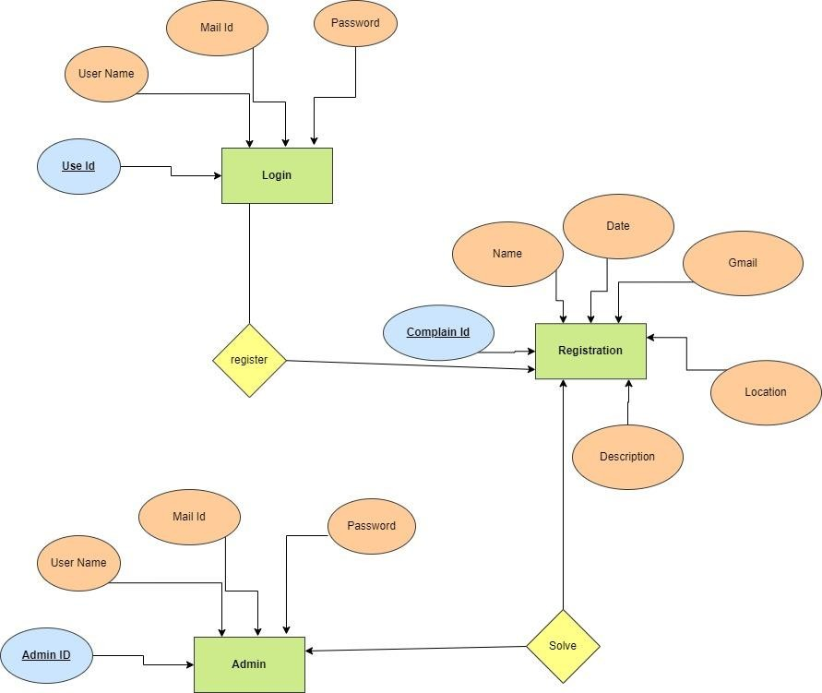

Fig 4.1 ER diagram

**4,2,2:Data Dictionary Sign up details:**

|  |  |  |  |
| --- | --- | --- | --- |
| **Field Name** | **Data Type** | **Description** | **Example** |
| Full Name | string | Name of the User | Nishar Khorajiya |
| Username | String | Name of the User | Nishar |
| Email | String | Email of the User | 21ce057@charusat.edu.in |
| Password | String | Password of the User | abc@123 |
|  |  |  |  |

**Login details:**

|  |  |  |  |
| --- | --- | --- | --- |
| **Field Name** | **Data Type** | **Description** | **Example** |
| Username | String | Name of the User | Nishar |
| Password | String | Password of the User | abc@123 |

**Feedback:**

|  |  |  |  |
| --- | --- | --- | --- |
| **Field Name** | **Data Type** | **Description** | **Example** |
| feedback | String | Message from user | Very good website!! |

## System Design

### Database Design/Data Structure Design

Login Table:

|  |  |  |
| --- | --- | --- |
| **Table name** | **Column Name** | **Type of Column** |
| Login users | ID | Number |
| Login users | Name | Varchar(30) |
| Login users | Password | Varchar(30) |

Signup Login Table:

|  |  |  |
| --- | --- | --- |
| **Table name** | **Column Name** | **Type of Column** |
| Register users | ID | Number |
| Register users | name | Varchar(40) |
| Register users | Gmail | Varchar(30) |
| Register users | password | Varchar(150) |

* 1. **Normalization**

## Conclusion and Discussion

This website is User-friendly Website through which we can order any product at least price and good quality.

Also on this website User can sell their products and get profit from it.

## References:

## Following Links are references:-

1. [**https://www.youtube.com/watch?v=YgHP_h8EyT4&t=45s**](https://www.youtube.com/watch?v=YgHP_h8EyT4&t=45s)
2. [**https://www.youtube.com/watch?v=yfpoT0YKSIc**](https://www.youtube.com/watch?v=yfpoT0YKSIc)

## List of Figures



Fig 1.1 User Login Page

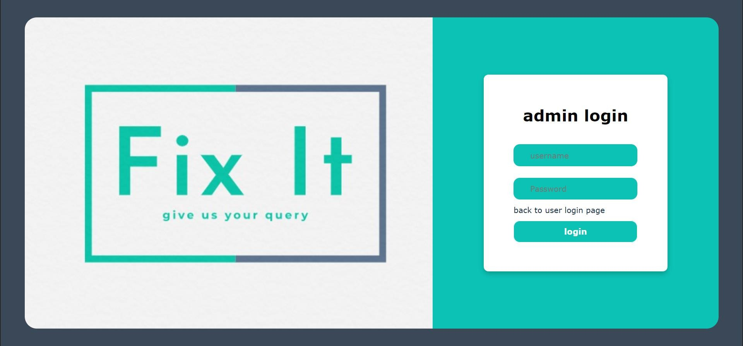

Fig 1.2 Admin Login Page

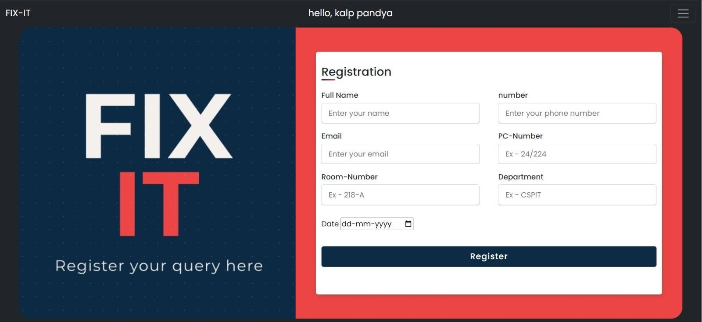

Fig 1.3 Registration Form



Fig 1.4 Successful registration

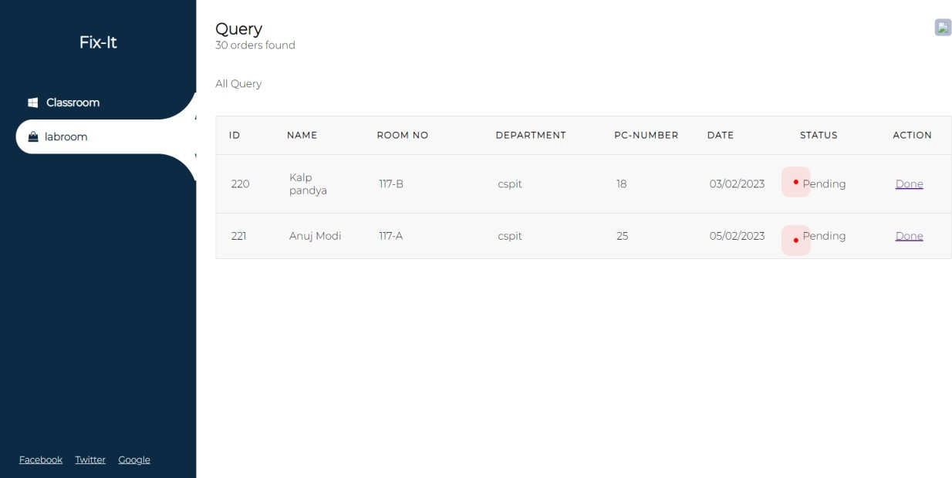t

**Sign up details:**

Fig 1.5 Successful registration

## List of Table

|  |  |  |  |
| --- | --- | --- | --- |
| **Field Name** | **Data Type** | **Description** | **Example** |
| Username | String | Name of the User | Om Nayi |
| Email | String | Email of the User | [21ce081@charusat.edu.in](mailto:21ce081@charusat.edu.in) |
| Password | String | Password of the User | om@123 |

**Login details:**

|  |  |  |  |
| --- | --- | --- | --- |
| **Field Name** | **Data Type** | **Description** | **Example** |
| Username | String | Name of the User | Om Nayi |
| Password | String | Password of the User | om@123 |

**Complaint Registration:**

|  |  |  |  |
| --- | --- | --- | --- |
| **Field Name** | **Data Type** | **Description** | **Example** |
| Name | String | Name of user | Om Nayi |
| Email | String | Email of the User | [21ce081@charusat.edu.in](mailto:21ce081@charusat.edu.in) |
| Phone number | String | Phone number of the  user | 1234567876 |
| Date | Date | date | 23/03/23 |
| PC no | string | Computer number in  lab | 15/15 |
| Room-number | String | Lab number | 618-A |
| Department | String | College department | CSPIT-CE |
| Description | String | Issue of user in detail | The mouse is broken |

**Feedback:**

|  |  |  |  |
| --- | --- | --- | --- |
| **Field Name** | **Data Type** | **Description** | **Example** |
| feedback | String | Message from user | Very good website!! |

1. **Books:**

## Bibliography

[The Joy of PHP: A Beginner's Guide to Programming Interactive Web Applications with PHP and](https://www.google.com/search?rlz=1C1YTUH_enIN990IN990&cs=1&sxsrf=APwXEddzQVpcHxf50u2ZDzAAW6WBe5oZ3w%3A1680201485779&q=The%2BJoy%2Bof%2BPHP%3A%2BA%2BBeginner%27s%2BGuide%2Bto%2BProgramming%2BInteractive%2BWeb%2BApplications%2Bwith%2BPHP%2Band%2BMySQL&stick=H4sIAAAAAAAAAFVTPWwURxi9teB0Xi6S76wAcjWYIsjN7f_eWkK2EyICshUbTiJVltuf2dvZ2Zn9GXZvrorS0iCK1EAVJHqkFMhKhwuKKEmZggJEEVGCFEWKD3nnnO3evvne9973zXTOrn82iAaq6ptaVNa5qnU9ShMAaQGySXYk_Z89krqfsGE5Tl27J1DzUpzbtdKc9szUREi1jyR5kA4Ua5gVjteQEJU8IS5pcDBN6jqa5SeH_RybsBZKdhFUxHIWjfTCD2bClkoIzBXW0JXLsIZ0IR3wADJP-IK2XzHTNU5aGRwX2GjIzDZsxrKhaFXank5QkwFiXjFhy1KGZUkEhpZVltEsWtjk0NEDAYmGM32ycJkkEV_Mtsynno6baSGVqdg9lRAjfeafwrmfDskiUoGwHQkeJnyqF1NlIa5YCjEcgY10hkoithG53AvMSj-ln00zLJIhL-ITRIRZFLHcDSZiA4hHhe27VoMTbmrJxEoazEpkTtyZqId6Nqw8OxX9IfJtR-Oi3jOy1NBEPhboEQumhcB1ntcK1MQm6oxBJdPFqLMCOcQ9NflpZaIG1oruDlOxCI_blopQo5XWNnJsD72WPkjnVt59_Gt17W_p4bOXf0pvJHlll9IyxPxWiMcsDEa0f15uf01YzHi_uybLnU-3REmq_o587nbIRnSPBjHkfa2vyMt7YeqFRfkt7F-W5a8oxqHPYkr6n6-tyr2BL34M5o-vXM-173_57adX7e96rePv4_1b22tXNnpy-xpNxzHpgecH_z6-83ZrY1XujMZTSmjKe0__6f1w8Oj91vql5eOauxeev9-aV2__rl09vCiBM1da6lzswx_24UbrwZL044uff213OtJKS1vqtDaXtqVZq_vk7Hg0CcFNygGFYP-b_U2wA74Mo5iQsPiiBNfvxUEIGAX7BY2KcZrGJAI3CAuL8bH_KgR3Qg_sZBmO_fE8TwnqmE3mQmBMArDHbx_sPmhL_wHSQguadgQAAA&sa=X&ved=2ahUKEwjU6talpoT-AhXTTWwGHamkB_0Q7fAIegUIABDWBA) [MySQL](https://www.google.com/search?rlz=1C1YTUH_enIN990IN990&cs=1&sxsrf=APwXEddzQVpcHxf50u2ZDzAAW6WBe5oZ3w%3A1680201485779&q=The%2BJoy%2Bof%2BPHP%3A%2BA%2BBeginner%27s%2BGuide%2Bto%2BProgramming%2BInteractive%2BWeb%2BApplications%2Bwith%2BPHP%2Band%2BMySQL&stick=H4sIAAAAAAAAAFVTPWwURxi9teB0Xi6S76wAcjWYIsjN7f_eWkK2EyICshUbTiJVltuf2dvZ2Zn9GXZvrorS0iCK1EAVJHqkFMhKhwuKKEmZggJEEVGCFEWKD3nnnO3evvne9973zXTOrn82iAaq6ptaVNa5qnU9ShMAaQGySXYk_Z89krqfsGE5Tl27J1DzUpzbtdKc9szUREi1jyR5kA4Ua5gVjteQEJU8IS5pcDBN6jqa5SeH_RybsBZKdhFUxHIWjfTCD2bClkoIzBXW0JXLsIZ0IR3wADJP-IK2XzHTNU5aGRwX2GjIzDZsxrKhaFXank5QkwFiXjFhy1KGZUkEhpZVltEsWtjk0NEDAYmGM32ycJkkEV_Mtsynno6baSGVqdg9lRAjfeafwrmfDskiUoGwHQkeJnyqF1NlIa5YCjEcgY10hkoithG53AvMSj-ln00zLJIhL-ITRIRZFLHcDSZiA4hHhe27VoMTbmrJxEoazEpkTtyZqId6Nqw8OxX9IfJtR-Oi3jOy1NBEPhboEQumhcB1ntcK1MQm6oxBJdPFqLMCOcQ9NflpZaIG1oruDlOxCI_blopQo5XWNnJsD72WPkjnVt59_Gt17W_p4bOXf0pvJHlll9IyxPxWiMcsDEa0f15uf01YzHi_uybLnU-3REmq_o587nbIRnSPBjHkfa2vyMt7YeqFRfkt7F-W5a8oxqHPYkr6n6-tyr2BL34M5o-vXM-173_57adX7e96rePv4_1b22tXNnpy-xpNxzHpgecH_z6-83ZrY1XujMZTSmjKe0__6f1w8Oj91vql5eOauxeev9-aV2__rl09vCiBM1da6lzswx_24UbrwZL044uff213OtJKS1vqtDaXtqVZq_vk7Hg0CcFNygGFYP-b_U2wA74Mo5iQsPiiBNfvxUEIGAX7BY2KcZrGJAI3CAuL8bH_KgR3Qg_sZBmO_fE8TwnqmE3mQmBMArDHbx_sPmhL_wHSQguadgQAAA&sa=X&ved=2ahUKEwjU6talpoT-AhXTTWwGHamkB_0Q7fAIegUIABDWBA)

### YouTube video:

It is video from ‘CodeWithHarry’ YouTube channel, <https://youtube.com/playlist?list=PLu0W_9lII9aikXkRE0WxDt1vozo3hnmtR>